Name:
Honors Fiction
Colecatraz

Short Story Creative Expression/Show Me What You Learned

We have covered a wide variety of texts including short stories, novellas, and novels. At the beginning of the semester you crafted a creative story. Now, it is time to revisit this story and focus on utilizing the skills you have picked up through your reading.

Step 1: Re-read and annotate your short story. Focus on: plot arc, symbolism, setting/mood, and devices such as foreshadowing and figurative language. Make note of the strengths and weaknesses of your plot arc.

Step 2: You are going to create either a visual story-board or a movie trailer focusing on plot arc, symbolism, and foreshadowing (the figurative language comes across).

Story Board: Create a story-board plan that shows the plot arc and devices. The
viewer of the board should be able to clearly see the plot arc as well as be able to
identify devices used. This should be visually appealing- one way to craft it is to use comic life!

Movie Trailer: Create a movie “trailer” that contains all aspects of the plot arc
and devices. You will need to include spoilers because a typical trailer does not
include the resolution, but for the purpose on this assignment please do so.

Grading: You will be scored on the original plot arc as well as on the following criteria:

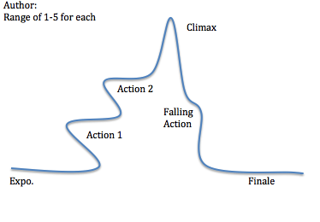
Student utilizes symbolism in the story and is able to visually represent it in an understandable way:
1 2 3 4 5

Student utilizes foreshadowing to enhance the story. It is neither blatant nor vague, it is able to help the viewer ease towards the conclusion:
1 2 3 4 5

Student creates a distinct setting/mood that enhances the impact of the story
1 2 3 4 5

Product is visually creative, neat, and complete
1 2 3 4 5

Comments:

