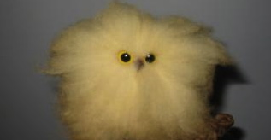

*Beginning your essay with anything remotely resembling: “Since the beginning of time,” “I read a book,” “I think”

*Including the following words or phrases or anything similar: I (unless you are writing a narrative), you, us, (basically any pronoun), many people, very (find an amazing adjective instead), throughout (so over used).

*SUMMARY. I (and all other teachers) assume you have read the book and we have read the books ourselves; do NOT recount the book. I want to see how you USE the book or reading to answer a question. How do you apply the concepts?

*Sentence. Fragments. Complete your. Thought.

*Mini paragraphs- figure out how to blend your ideas.
Instead of chopping them.
Up.

*Careless or non-existent editing. Take pride in your work and edit!

*Fluff. Fluff is so hard to get through and it sticks to everything. Cut the excess words and focus on the meat. Flowery unnecessary language is like wading through a swamp filled with Jell-O and molasses.

