Characterization Visual
Colecatraz
CP Fiction

Now that you have created your character and a conflict, you need to create a representation of your character. Your representation should show (in some way) your characters best and worst traits as well as the conflict he/she creates because of his/her personality. This visual can be a painting, sculpture, video, soundtrack, drawing, diorama, or anything else you can think of (the more creative the better). This should show time and effort. Take ownership and pride in your work!
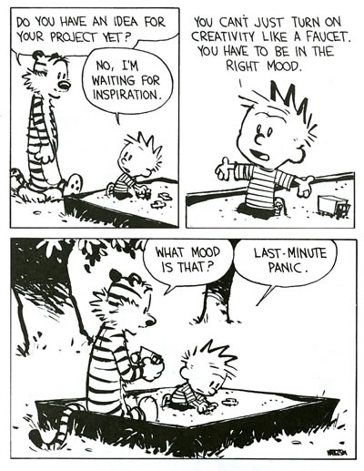
Characterization Visual
Colecatraz
CP Fiction

Now that you have created your character and a conflict, you need to create a representation of your character. Your representation should show (in some way) your characters best and worst traits as well as the conflict he/she creates because of his/her personality. This visual can be a painting, sculpture, video, soundtrack, drawing, diorama, or anything else you can think of (the more creative the better). This should show time and effort. Take ownership and pride in your work!

